Machine Learning Lab: Decision Tree
Name : Abu Bakar Sadiq
Program and Section : AI ‘B’
Assignment 08

Part A: Results Table
Run | TEST_SIZE | MAX_DEPTH | SEED | Train accuracy | Test accuracy | Wrong predictions
1 (original) | 0.3 | 3 | 1 | 0.981 | 0.956 | 2 out of 45
2 | 0.3 | 1 | 1 | 0.695 | 0.600 | 18 out of 45
3 | 0.3 | 2 | 1 | 0.962 | 0.956 | 2 out of 45
4 | 0.3 | 8 | 1 | 1.000 | 0.956 | 2 out of 45
5 | 0.5 | 3 | 1 | 0.973 | 0.973 | 2 out of 75
6 | 0.1 | 3 | 1 | 0.970 | 1.000 | 0 out of 15
7 | 0.3 | 3 | 7 | 0.981 | 0.889 | 5 out of 45
8 | 0.3 | 3 | 42 | 0.952 | 0.978 | 1 out of 45

Tree Screenshots
Run 1 (MAX_DEPTH = 3)
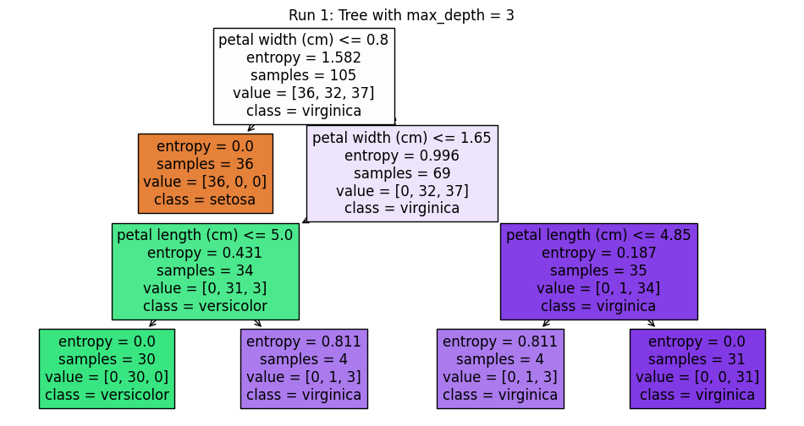
Run 2 (MAX_DEPTH = 1)
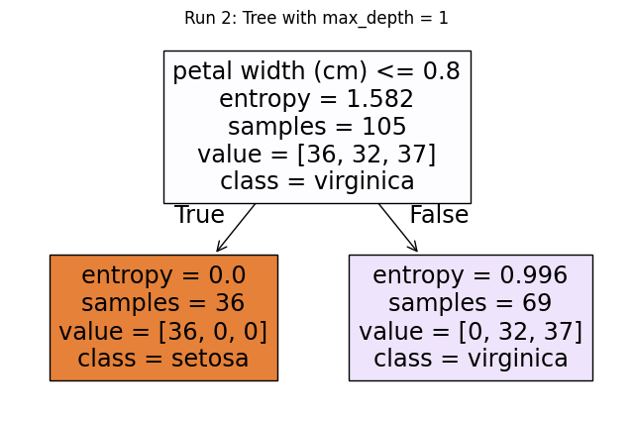
Run 4 (MAX_DEPTH = 8)
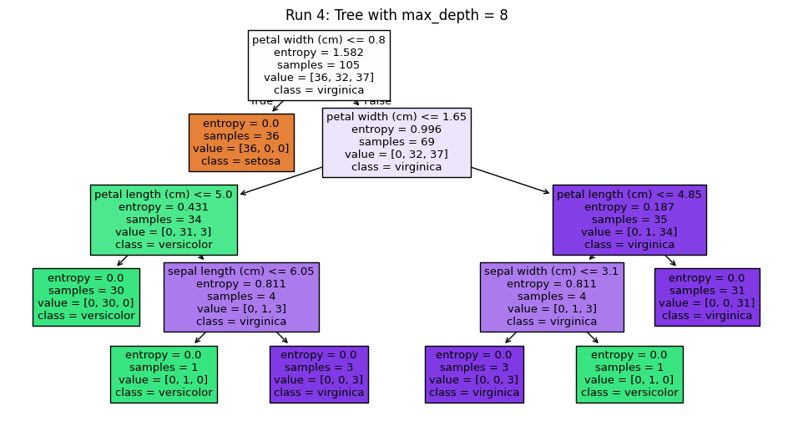

Part B: Questions
- With MAX_DEPTH = 1 the tree asks only one question (petal width <= 0.8). It separates setosa, but the other box still mixes 32 versicolor and 37 virginica, so one question cannot separate three classes. Train accuracy is 0.695 and test accuracy is 0.600.
- Training accuracy rises with depth: 0.962 (depth 2), 0.981 (depth 3), 1.000 (depth 8). Test accuracy stays at 0.956 for all three. A deeper tree only memorizes the training data (overfitting), so it does not help on new data.
- Each seed puts different rows in the test set, so test accuracy changed: 0.956 (seed 1), 0.889 (seed 7), 0.978 (seed 42). One split can be lucky or unlucky, so we should not trust a single split.
- On 15 rows one wrong prediction changes accuracy by about 6.7%, but on 75 rows by only 1.3%. A small test set gives a noisy result, a bigger one is more stable.
- The box with entropy = 0.0 has samples = 36 and value = [36, 0, 0] (all setosa). It is a pure box, so the tree stops splitting and makes it a leaf that predicts setosa.
- The root split is on petal width (cm) <= 0.8. It has the highest information gain (biggest drop from the starting entropy of 1.582), and it separates all setosa samples into one pure box.
7. With criterion = "gini" the accuracy did not change (train 0.981, test 0.956, 2 wrong) and the tree had the same splits. The attribute selection measure used was the Gini index (Gini impurity).

Part C: Entropy by Hand
Output of the two lines:
entropy(["yes"] * 4) = 0.0
entropy(["yes"] * 4 + ["no"] * 4) = 1.0
They are different because a pure group has only one class, so there is no uncertainty (0), while a 50/50 group is the most mixed, so uncertainty is maximum (1).
After changing the second line to 7 "yes" and 1 "no", the output is 0.5436. The entropy goes down compared with 4 and 4, because the group is less mixed.

